Lab session on Monday
- Create an image of size 800 X 800 with all pixel values as one. Now create black squares within the image of size 100 X 100 such a way that the image becomes a chessboard. On this image perform the following:
(a) Make two copies of the image and add noise V1 - gaussian, zero mean, variance is 0.1 and noise V2 - gaussian, zero mean, variance is 0.01 . Now you have three images: Original, Noise V1 added image, Noise V2 added image
(b) Detect the edges in the image using (i) LoG (ii) Canny (iii) Sobel (iv) Prewitt (v) Roberts
(c) Compare how well these edge detectors can perform in presence of noise.
(d) Observe and come up with a technique/algorithm/a quantifying measure to determine how good each of these edge detectors are in obtaining the edges in these three images. Hence, it should be able to distinguish between good edge map from bad edge map. (Edge map is binary image where one corresponds to edges and are obtained as a result of edge detector)
Compare edge maps -> statistical edge map.

- An image of a bitten apple (apple company logo) is given. Draw a contour around the bitten apple

- Natural images and synthetic images are given. perform the following:
(a) Obtain the Fourier transform of all the images.
(b) Plot the average power spectrum (square of magnitude of Fourier transform) of the 2 classes of images. Comment on the differences in the averaged power spectrum of natural images and synthetic image classes?
(c) Now obtain the magnitude and phase plot and reconstruct the images but from a mix of the phase plots and magnitude plots such that if m1, m2 are magnitude plots of image 1 and image 2 and p1, p2 are phase plots of image 1 and image 2, reconstruct using (m1 and p2) and (m2 and p2). What do you observe? Phase is more important than magnitude.
(d) From the spectrum, utilize only those frequencies falling within the unit circle and reconstruct. What do you observe? Carry out the same for frequencies within the circles of 1.5 radius, 0.5 radius, 2 radius and so on. What are the observations?
Unit circle-> how much information. How much original can we get.
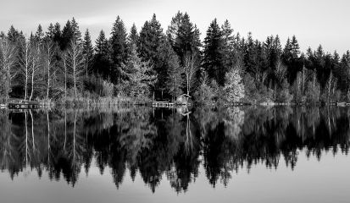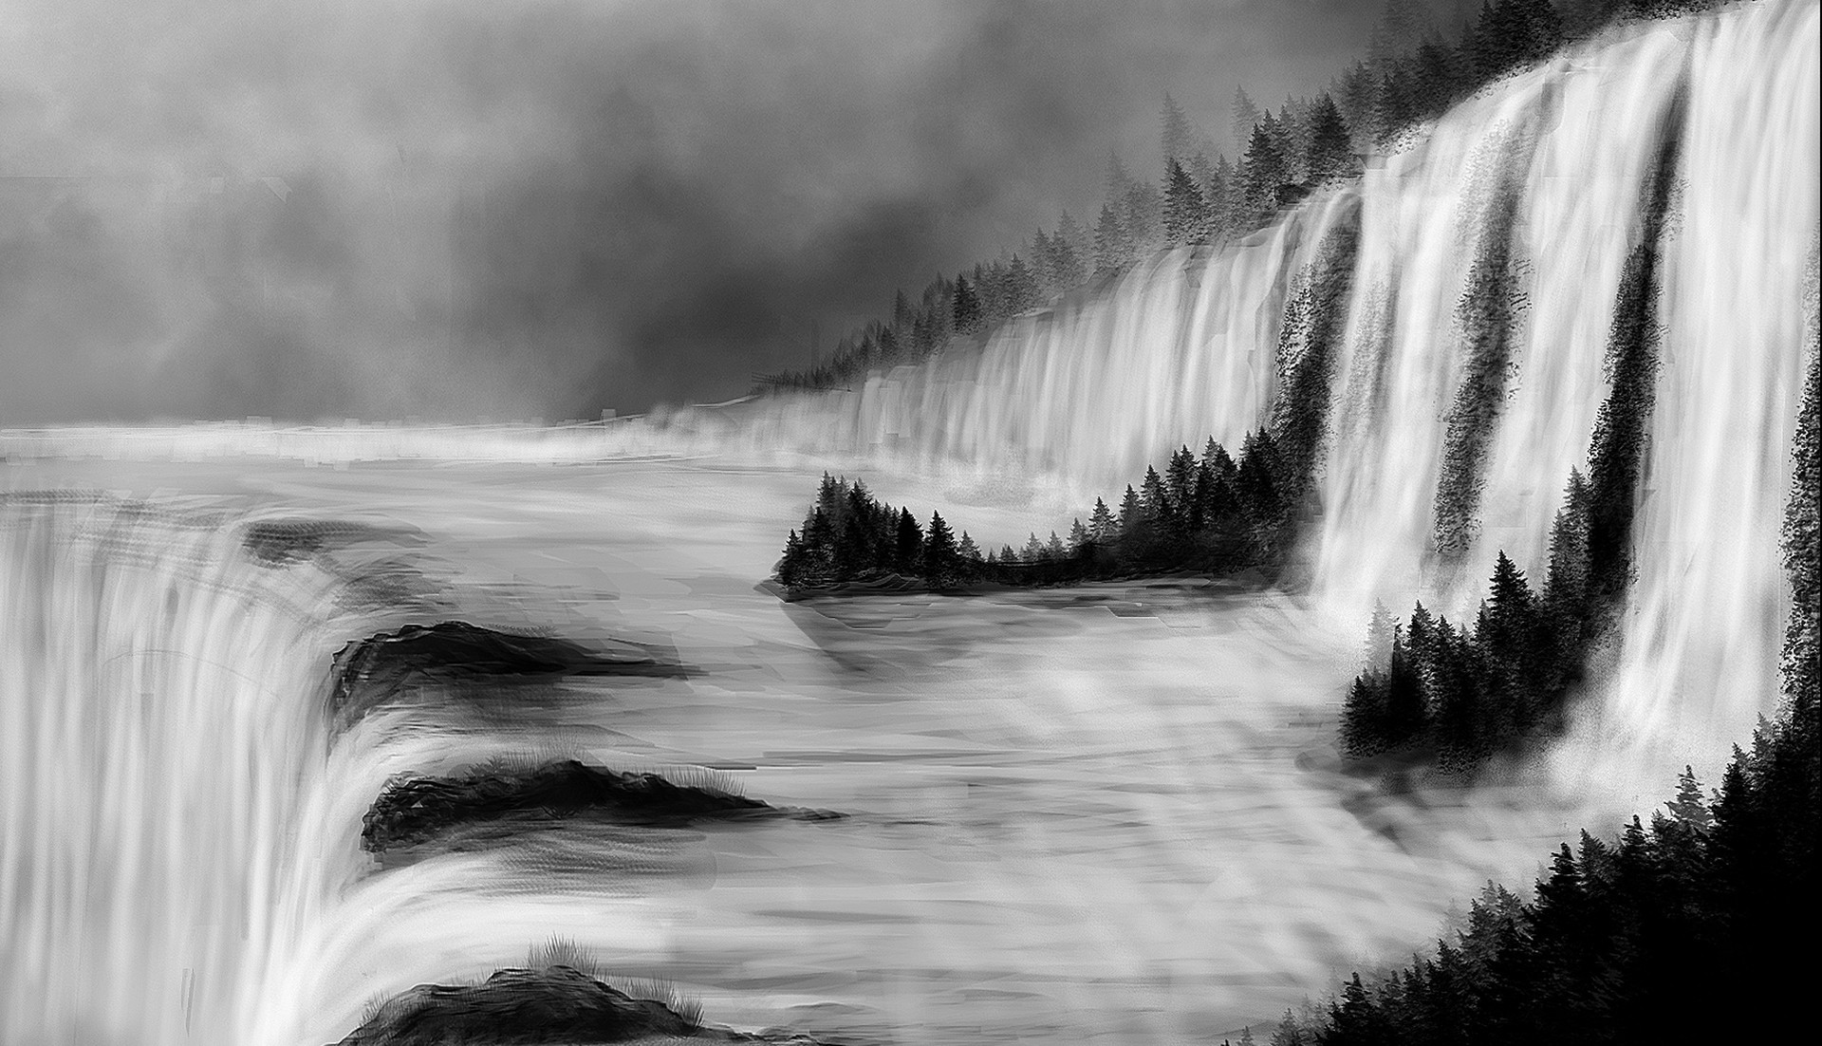

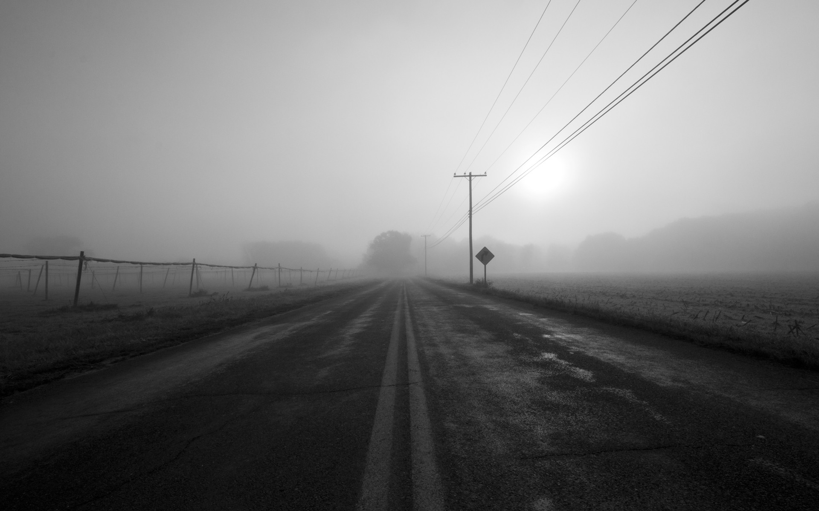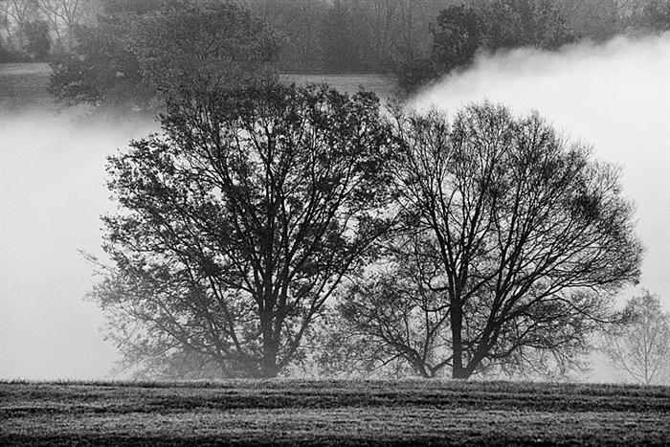

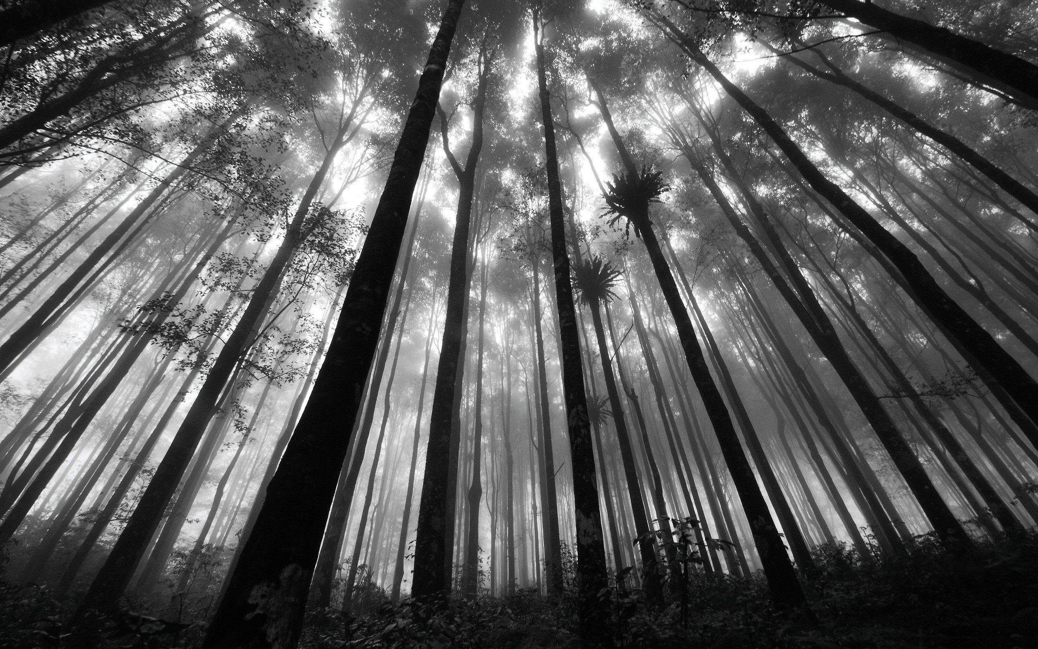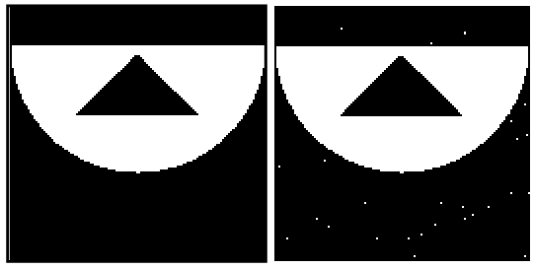

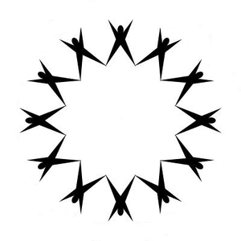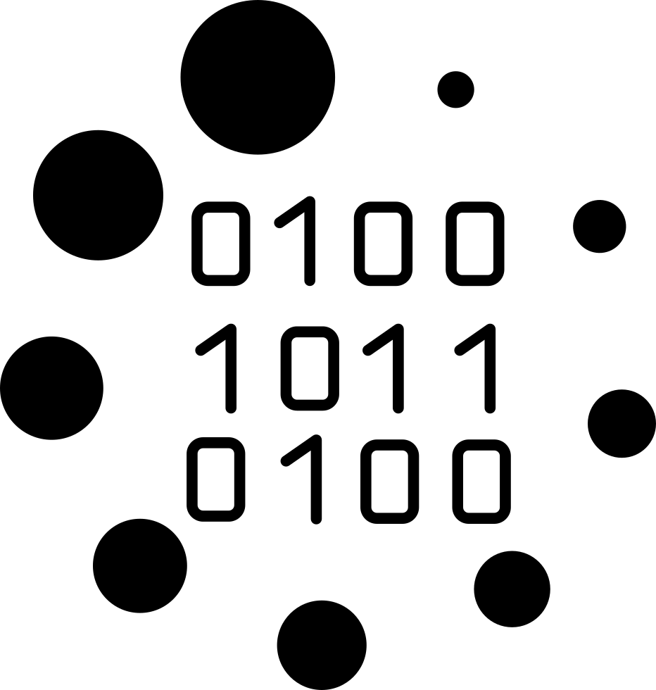

- Given an RBG image, extract the flowers, stems and blue sky separately by the method of thresholding on each of the channels in RGB colour space. (Use otsu's thresholding). Apart from Otsu, try other thresholding scheme.

